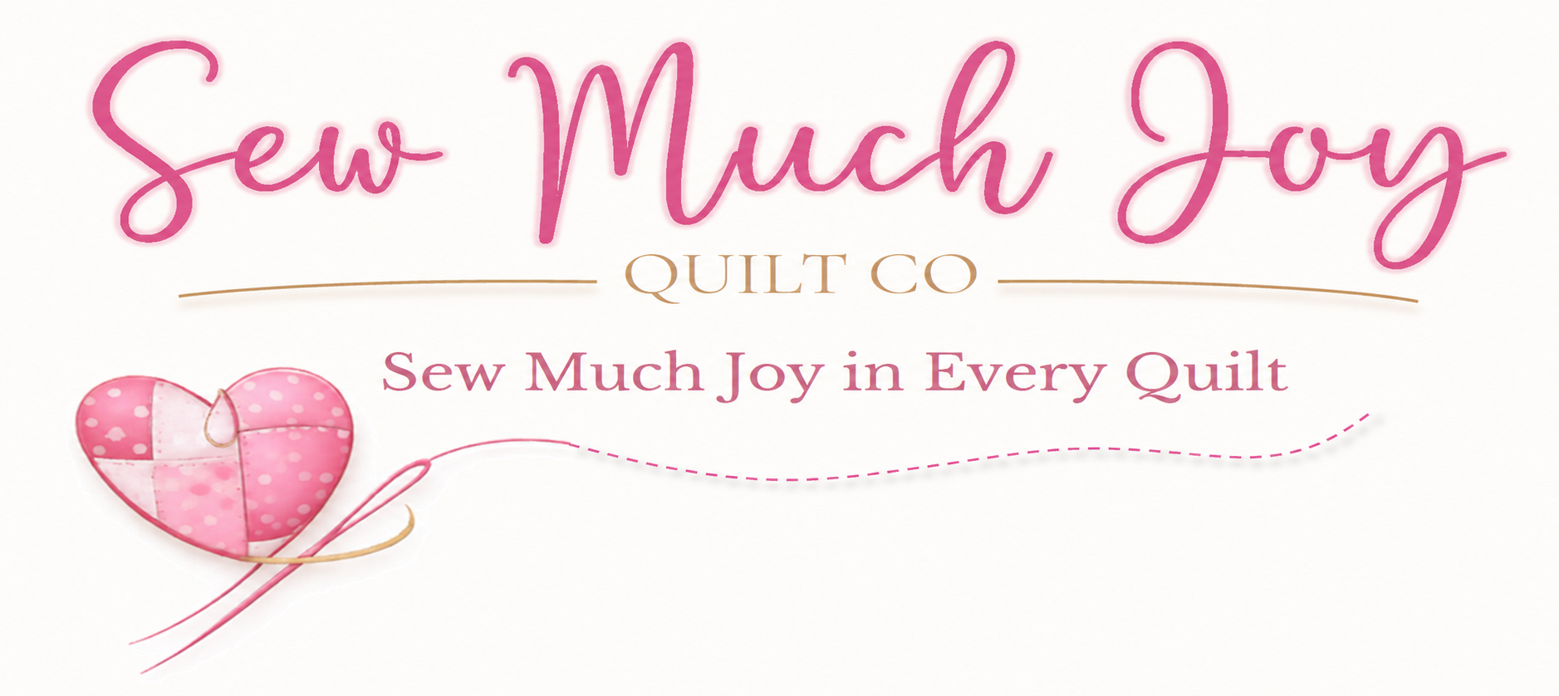
Longarm Quilting Pricing

Standard Turnaround: 3-4 weeks.
Payment is due at time of pickup. (Cash; Check; Venmo; Apple Pay all fine)

Quilting service | Through Dec 31, 2026 | From Jan 1, 2027
Edge-to-edge medium density | $0.015 / sq. inch | $0.020 / sq. inch
Edge-to-edge heavy density | $0.020 / sq. inch | $0.025 / sq. inch
Simple custom (borders / blocks) | $0.030 / sq. inch | $0.030 / sq. inch
Custom quilting by design | $0.050 / sq. inch | $0.050 / sq. inch

Quilting Charge Example = Quilt width x length (inches) x Rate($): 75” x 80” x $0.020 = $120
$25 minimum applies.

I am happy to supply batting. All batting listed is an 80/20 cotton/poly blend. Other batting types (wool, bamboo, black, etc.) are available upon request. (Quilt top plus 5-8” additional length and width)
Batting Size (Inches) |  | Hobbs | Quilters Dream  Natural | Quilters Dream  White
Crib / Throw | Up to 60 x 60 | $13.00 | $17.00 | $17.00
Twin / Full | Up to 93x96 | $26.00 | $38.00 | $42.00
Queen / Double | Up to 93 x 108 | $30.00 | $40.00 | $42.00
Super Queen / King | Up to 120 x 122 | $36.00 | $56.00 | $60.00

Additional Services | Charge
Minimum quilting charge | $25
Additional thread colors | $5 each
Rush service | $25
Backing piecing (up to 2 seams) | $10
Trim Batting/Backing Flush with top | Free (on request)
Binding | Not offered at this time

